**Problem of the Week # 4**

**Pumpkins Full of Coins**

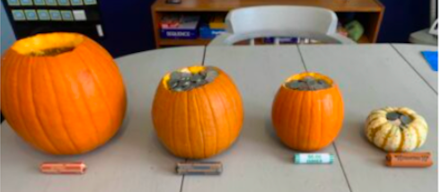

**Which pumpkin holds the most money:**

the extra large pumpkin filled with 400 pennies;

the large pumpkin filled with 87 nickels;

the small pumpkin filled with 43 dimes;

or

the mini pumpkin filled with 17 quarters?

**Show your thinking using pictures, words, or numbers.**